附件1：会议论文详细摘要格式（鼓励用英文撰写）
Title of manuscripts (Times New Roman三号，加粗，居中)
Xingzhong Guo, Lu Chen, Mankang Zhu（Times New Roman小四，居中）
(School of Materials Science and Engineering of Zhejiang University, Hangzhou P.R. China 310058) （Times New Roman，五号，居中，斜体）

Abstract: (Times New Roman，五号，加粗) Follow this order when typing manuscripts: Title, Authors, Affiliations, Abstract, Keywords, Figure Captions or Tables, References. Each paper should be provided with an Abstract of about 200- 500 words, reporting concisely on the purpose and results of each paper. Immediately after the abstract, provide a maximum of 3~4 keywords and 3~4 references cited in the abstract. (Times New Roman，五号)
Keyword: (Times New Roman，五号，加粗) Ceramic, glass, powder, sol-gel (Times New Roman，五号)
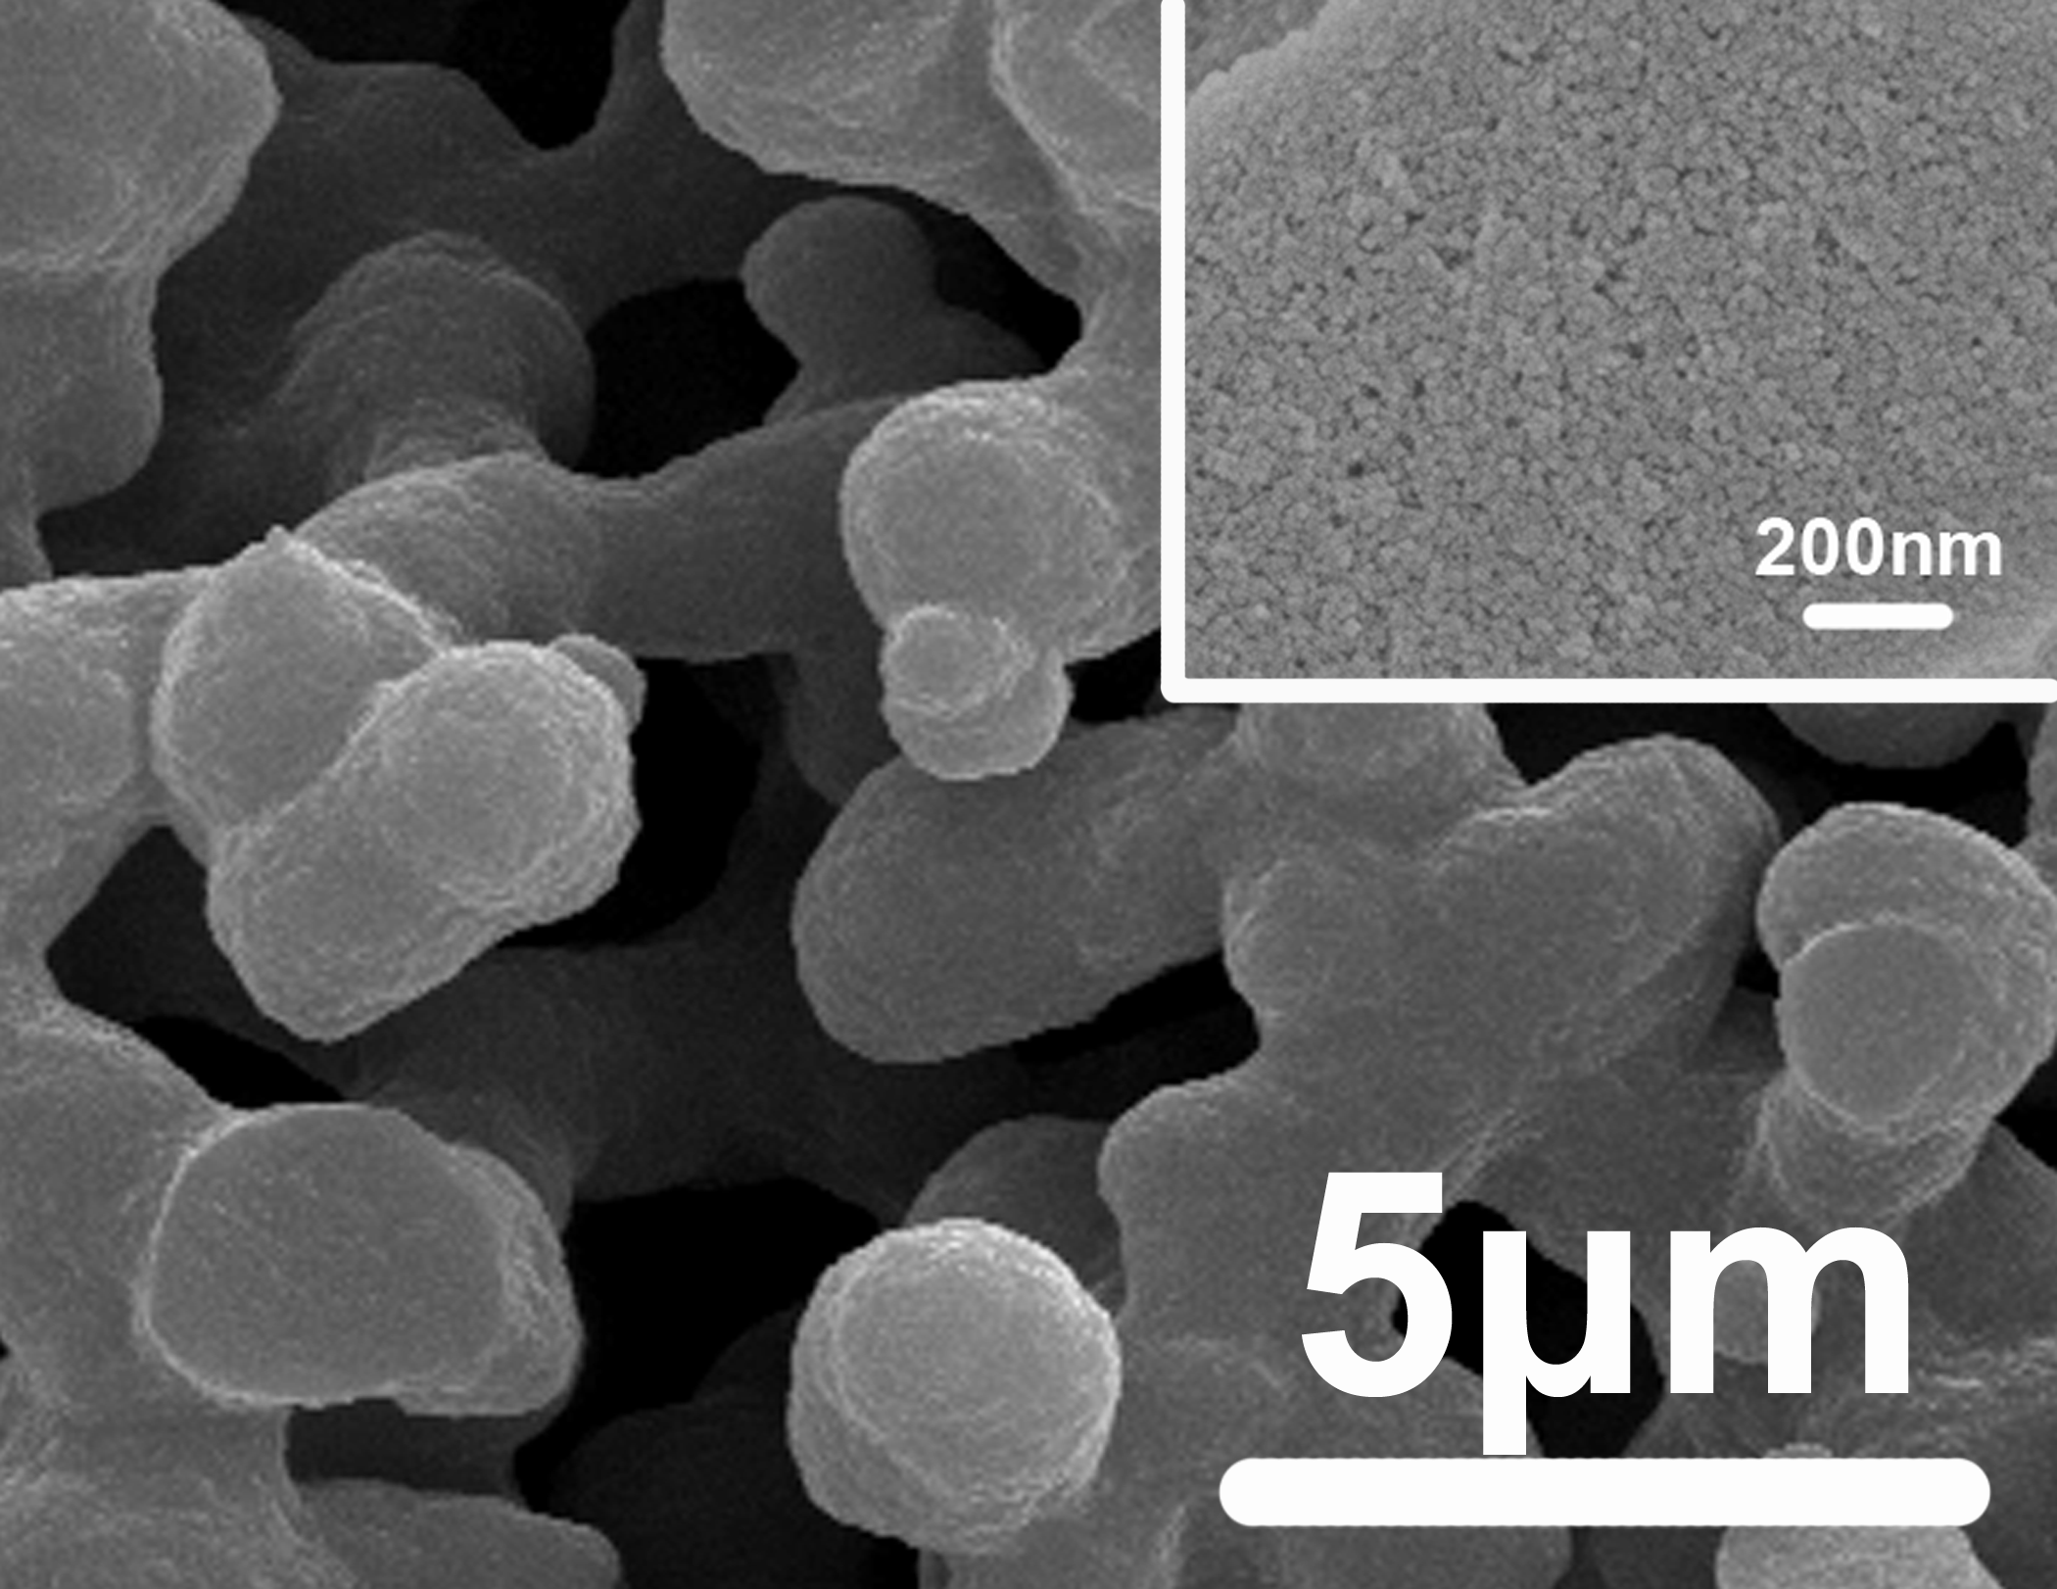
Fig. 1 SEM images of hierarchically silica monolith (Times New Roman, 小五，图片请用.JPG格式）
and /or
Table 1: Compositions of Ceramics % (Times New Roman,小五)
Al₂O₃(Times New Roman,小五) | Y₂O₃ (Times New Roman,小五)

References: (Times New Roman，小五，加粗)
[1] Jingsong Yu, Xiaoqian Qian, Qingsong Ma et al. J Chin Ceram Soc, 1999, 27(3): 365-368.
[2] P.W. McMILAN. Glass ceramics, Beijing: Academic Press, 1979.
（Times New Roman,小五）

Project:( Times New Roman, 小五，加粗)：High Sci & Tech Brainstorm Project (No. )(Times New Roman,小五)
Corresponding author(Times New Roman, 小五，加粗)：Xingzhong Guo, Tel: 86-571-87953313, Fax: Tel: 86-571-87953313, E-Mail: msewj01@zju.edu.cn. (Times New Roman,小五)

