附件1：会议论文详细摘要格式（鼓励用英文撰写）
Title of manuscripts (Times New Roman三号，加粗，居中)
Author 1 Author 2 Author 3 （Times New Roman小四，居中）
(Department of Materials Science and Engineering of Zhejiang University, Hangzhou P.R. China 310027) （Times New Roman，五号，居中，斜体）

Abstract: (Times New Roman，五号，加粗) Follow this order when typing manuscripts: Title, Authors, Affiliations, Abstract, Keywords, Figure Captions or Tables, References. Each paper should be provided with an Abstract of about 200- 500 words, reporting concisely on the purpose and results of each paper. Immediately after the abstract, provide a maximum of 3~4 keywords and 3~4 references cited in the abstract. (Times New Roman，五号)
Keyword: (Times New Roman，五号，加粗) Ceramic, glass, powder, sol-gel (Times New Roman，五号)
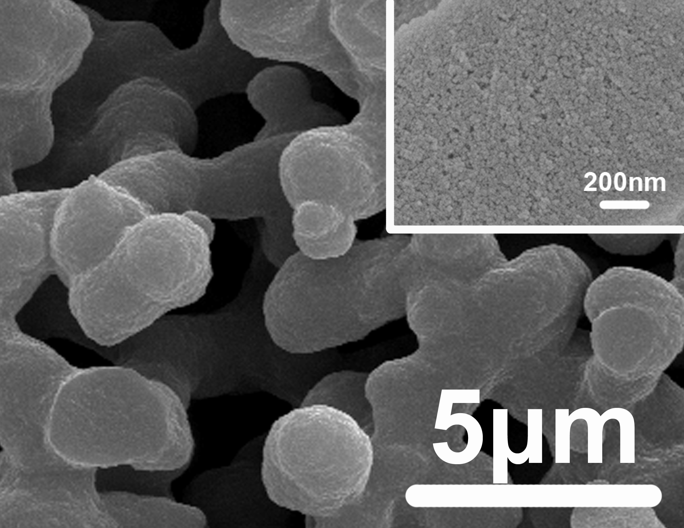
Fig. 1 SEM images of hierarchically silica monolith (Times New Roman,小五，图片请用.JPG格式）
and /or
Table 1: Compositions of Ceramics % (Times New Roman,小五)
Al₂O₃(Times New Roman,小五) | Y₂O₃ (Times New Roman,小五)

References: (Times New Roman，小五，加粗)
[1] YU Jingsong, QIAN Xiaoqian, MA Qingsong et al. J Chin Ceram Soc, 1999, 27(3): 365-368.
[2] P.W. McMILAN. Glass ceramics, Beijing: Academic Press, 1979.
[3] N. Ekinaga, Characteristics of SiC whisker and their applications, Proceedings of the 1st Japan International SAME Symposium, 1989: 883-888.
（Times New Roman,小五）

Project:( Times New Roman, 小五，加粗)：High Sci & Tech Brainstorm Project (No. )(Times New Roman,小五)
Corresponding author(Times New Roman, 小五，加粗)：Guo Xing-zhong, Tel: 86-571-87953313, Fax: Tel: 86-571-87953313, E-Mail: msewj01@zju.edu.cn. (Times New Roman,小五)

